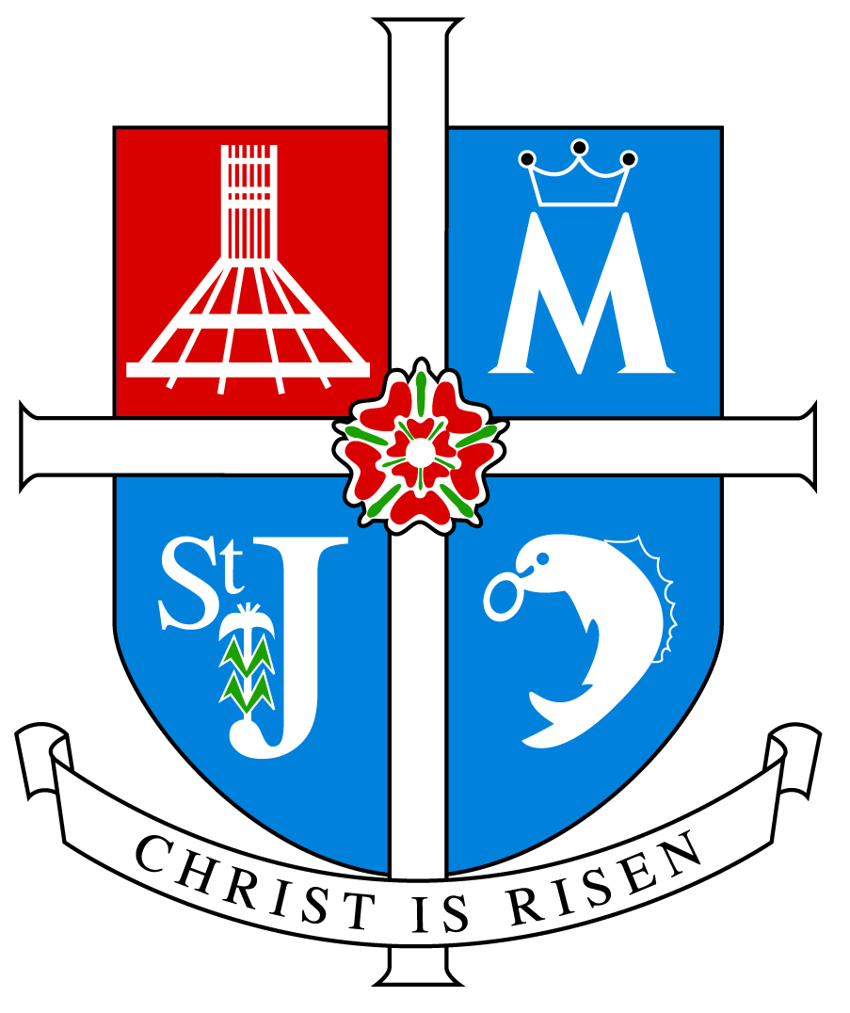

ARCHDIOCESE OF LIVERPOOL

INSPECTION REPORT

ST. JOHN FISHER CATHOLIC PRIMARY SCHOOL

KNOWSLEY

Inspection Date Tuesday 6th November 2012
Inspectors Miss Julie Lockett Mrs Maria Eves

Unique Reference Number 104476

Inspection carried out under Section 48 of the Education Acts 2005 and 2011
____________________________________________________________

Type of School Catholic Primary

Age range of pupils 4-11

Number on roll 173

Chair of Governors Mr J W Leake MBE, JP

Headteacher Mrs J M Farrimond

School address Tithebarn Road
Knowsley
Prescot
L34 0HA

Telephone number 0151 477 8590

E-mail address stjohnfisher.de@knowsley.gov.uk

Date of last inspection 24th April 2007

Introduction

This inspection was carried out under Section 48 of the Education Acts 2005 and 2011

The report of the inspection is produced for the Archbishop of Liverpool (Code of Canon Law 804 and 806) and for the governors of the school.

The inspectors are members of the Christian Education Department and their associates approved by the Archbishop of Liverpool for this purpose.

Information about this school

- St John Fisher School is a smaller than average sized Catholic Primary School situated in the village of Knowsley and serves the parish of St John Fisher and the wider surrounding area.
- There are 173 children on roll of whom 147 are baptised Catholic, 25 come from other Christian denominations, and 1 from other faith or religious traditions.
- There are 9 teachers of whom 9 teach Religious Education. Six are Catholic. Six teachers have a suitable qualification in Religious Education and 3 teachers are currently studying for the Catholic Certificate in Religious Studies
- Since the last inspection there has been a significant change in personnel. There is a new headteacher and chair of governors. There is a team, lead by the deputy headteacher, dedicated to co-ordinating Religious Education which includes a newly appointed Key Stage One manager.

Key for inspection grades

Grade 1 Outstanding
Grade 2 Good
Grade 3 Requires Improvement
Grade 4 Inadequate
______________________________________________________________

© 2012 copyright – Archdiocese of Liverpool. This document may be reproduced in whole or in part for non-commercial educational purposes, provided that the information quoted is reproduced without adaptation and the source and date of publication are stated.

Further copies of this report are obtainable from the school.

Overall effectiveness:

St. John Fisher Catholic Primary is an outstanding school in providing Catholic Education.

Inspection Judgements

The extent to which the pupils contribute to and benefit from the Catholic life of the school.

- Pupils show an outstanding knowledge and understanding of the schools Mission Statement and understand the part they play within it. They are actively involved in its evaluation.
- Pupils have a strong sense of belonging to the school community and value and respect others, evident in their role to evaluate and aid the writing of the school’s ‘Vision Prayer’
- Pupils embrace opportunities to meet their potential in all aspects of school life and are actively involved in developing the Catholic character of the school.
- Pupils are encouraged to take on roles of responsibility in the school and wider community. Through, for example, pupils lead a Fisher Fund Raiser to raise money for charities of their own choice. The school council and Year 6 Responsibility Scheme provide pupils with the opportunity to participate in decision making.
- Pupils benefit from participation in away days and retreat activities such as attendance to the Big Assembly as part of the Papal visit.
- Pupils are involved in service to the local and wider communities. For example, pupils participate in a local Ecumenical Service; they fundraise and collect for the Knowsley Food bank, CAFOD and choir visits to ‘Whiston Hospital’.
- Education for pastoral care and personal relationships has fostered positive attitudes in pupils. Pupils have a good sense of right and wrong and apply this in their personal relationships.
- Pupils take an increasing responsibility for themselves and their actions. How pupils treat one another is celebrated in weekly reflections. Pupils’ behaviour is outstanding.
- They praise and acknowledge the contribution of others. They show a readiness to embrace and celebrate their lived experiences.

How well pupils’ achieve and enjoy their learning in Religious Education

- On entry to school many children have a limited knowledge and understanding of the Catholic faith.
- Pupils’ achievement in Religious Education is mostly above average.
- Pupils’ attainment in Religious Education is generally above average. Pupils make good progress in relation to their starting points and capabilities.
- There is no difference in performance between pupils of different gender.
- Outcomes for pupils with additional or special needs are good.
- Analysis of assessments undertaken provides evidence of pupils generally attaining appropriate levels for their age and stage of development in each key stage.
- Moderation for formal assessment tasks show pupils’ good understanding for the lower attainment levels and an increasing understanding for higher levels of attainment.
- Pupils are becoming increasingly more religiously literate. Their knowledge, understanding and skills are developing appropriate to their age or capacity.
- They are developing the skills that enable them to reflect spiritually, think ethically and theologically and are becoming more aware of the demands of religious commitment in everyday life.
- Pupils’ engagement in and enjoyment of their learning is good as shown by their interest, enthusiasm and outstanding behaviour. Pupils’ are highly supportive of each others’ learning.
- Pupils work collaboratively through talking partners and group work which supports and encourages their learning and is a tool used effectively throughout the school to reinforce prior learning.
- Pupils are inspired, enthused and are anxious to learn and improve their knowledge, understanding and skills. They are equipped to progress independently and tackle challenging learning.

How well pupils’ respond to and participate in Collective Worship

- Pupils are outstanding in their responses and participation in Collective Worship.
- They act with reverence and are keen to participate in a variety of gatherings.
- Pupils’ knowledge of prayer and liturgy is increasing.
- A children’s Mass is celebrated once a term by the local Parish Priest.
- They become familiar with a variety of prayer styles. They appreciate and are open to the Word of God in the scriptures.
- They sing joyfully, reflect in silence and join in community prayers appropriately and with confidence.
- They are becoming increasingly more confident preparing and leading worship. This is evident through pupils own planning in Key Stage Two and their supporting roles in Key Stage One.
- Pupils’ are encouraged to contribute to the school prayer book and pupils’ contributions are added to regular newsletters home. This act of worship allows pupils the freedom to create their own connection to meaningful prayer.
- Pupils’ personal contributions to prayer ensure the school community are able to ‘live in faith’.

The quality of teaching and how purposeful learning is in Religious Education

- The quality of teaching is outstanding and consistently effective in ensuring that pupils are interested and engaged.
- Teachers display excellent subject knowledge and deploy a range of teaching styles to motivate and inspire pupils.
- In lessons observed, effective questioning and appropriate timing ensured pace and all pupils were engaged.
- Excellent opportunities are given for pupils to reflect on their learning and link it to their own lives, for example, in a plenary session; pupils consolidated the learning intention through meaningful reflection and were guided to live with the light of Christ.
- Teaching encourages pupils’ enjoyment of and enthusiasm of Religious Education. For example, pupils were able to gain an excellent understanding of being guided by the Holy Spirit. A practical introduction captured the pupils’ attention, enabling exploration and reflection.
- Teachers give a high priority to pupils’ prior learning, for example, role play of a Baptism was recorded and observed to consolidate and build upon learning.
- Planning whether annotated or on planners shows good content and evaluations. Planning is improving and evolving to ensure good content and evaluations which will continue to develop due to the introduction of the new Religious Education programme, ‘Come and See.’
- Planning ensures differentiated tasks so that the work consolidates, builds and extends their knowledge and understanding. In the Foundation Stage, themes are effectively reinforced through appropriate continuous provision
- Teachers provide excellent opportunities for pupils to work collaboratively and at times independently. Good quality resources are used within lessons and teachers use a variety of Information Communication Technology to maximise learning.
- Teaching Assistants provide outstanding care and support to pupils. They are deployed effectively and show sensitivity to pupils needs. In lessons observed they ensured all pupils in their care reach their full potential.
- Pupils are informed of their progress and how to improve both orally and through a self assessment ‘traffic light’ system. Marking shows some opportunities that children are responding to teachers’ feedback.
- Pupils are given opportunities to discuss their work and are becoming aware of the use of ‘driver words’ to improve the content of their work.
- Effort and achievement at all stages of learning is celebrated.
- The school tracks achievement of all the pupils and has begun an improved process of tracking formal assessments.

The extent to which the Religious Education Curriculum promotes pupils’ learning

- The curriculum is good in meeting pupils’ needs and the school has successfully implemented the new Religious Education Programme, ‘Come and See’
- The school using the Come and See programme recommended by the Archdiocese meets the requirements of the Religious Education Curriculum Directory. Appropriate levels of the programme are being followed in different classes. This ensures complete Religious Education entitlement for each child and meets National and Archdiocesan requirements.
- Of the total curriculum time 10% is allocated to Religious Education. This fulfils the requirements of the Bishops of England and Wales.
- Planning ensures full coverage of the Religious Education programme. Imaginative and well planned strategies are deployed to enrich and stimulate pupils learning.
- The curriculum supports the needs of groups and individuals. The new Religious Education Programme, will provide opportunities to match the higher level learners to more challenging and independent tasks
- Children have explored the beliefs and values of other faiths and religions. This helps to promote tolerance and respect for those who think differently. The school invites visitors from the Jewish faith into school and has a two year cycle for Hinduism and Islam. The school’s creative curriculum allows for multi cultural days and the school has promoted links to countries of Islamic faith.
- Enrichment activities such as residential visits to Shrewsbury and Colomendy have positive impact on the curriculum.
- The Religious Education curriculum provides opportunities for pupils’ spiritual, moral development and vocation, such as, weekly reflection time linked to the schools’ Mission Statement and Vision Prayer, development of a peace garden through the Eco Club and regular class reflections, following Religious Education topics covered.

The quality of Collective Worship provided by the school.

- Collective Worship has a high profile and is central to the life of St John Fisher.
- The Collective Worship provided is outstanding in reflecting the Catholic character of the school.
- The school provides opportunities for staff to develop the skills in planning, leading and evaluating Collective Worship. There has been recent training received for Collective Worship and each theme begins with ‘Come and See for Yourself’.
- Children are enabled to pray formally and informally using a variety of prayer methods and styles.
- The teachers provide quality resources and opportunities to help children to develop the skills necessary to plan, lead and participate in Collective Worship and to evaluate it effectively.
- Collective Worship plays a key part in meeting the spiritual needs of the pupils.
- Opportunities are provided to enable full, active and conscious participation of the whole school community. The school prayer book also welcomes parent contributions.
- Opportunities are provided for parents and carers to participate in a variety of celebrations of the Come and See programme and the Church’s liturgical year.
- St John Fisher actively seeks to welcome the whole school community as a place of worship in familiar surroundings.

How well leaders, governors and managers promote, monitor and evaluate the provision for the Catholic Life of the school and plan and implement improvement to outcomes for pupils.

- Leaders, governors and managers are outstanding in promoting and developing the Catholic life of the school and are deeply committed to the Mission of the Church.
- This is reflected in the Schools own Mission Statement. All who form part of the school community including parents, Priests, governors and children were involved in the development of the Mission Statement it guides every aspect of school life and is a useful tool by which the school evaluates its effectiveness.
- The Mission Statement has undergone a recent interim review and a full review is due next year. The school community is also guided by their ‘Vision Prayer’. This is displayed prominently throughout the school and is used to support and steer the whole school community.
- Religious Education is led by a senior manager, supported by the Deputy Headteacher, a learning mentor and teaching assistant. This is a dedicated team, who drive forward changes and provide input from various standpoints relating to their roles within the school community.
- Opportunities are provided for the staff and pupils to play an active part in Catholic life and Mission of the school e.g. the schools’ ‘Vision Prayer’ was formed through staff and governor retreat, leading to pupils’ own input.
- St John Fisher school community know, own and live out their Mission Statement – ‘to live in faith and learn in love together’, as each new challenge is approached through teamwork. The relationships within school are palpable, ‘there is a strong team spirit because staff feel valued and empowered.’
- Leaders, governors and managers use monitoring data effectively to evaluate the schools performance, celebrate, and plan future improvements.
- The detailed Self Evaluation Document provides evidence of the schools monitoring, searching analysis and self challenge. Areas for improvement are identified and fed into the schools’ improvement planning. The Religious Education Team produce a comprehensive Action Plan and further detail of timescales would strengthen this process
- Their analysis provides a basis to celebrate the schools strengths and outlining areas for development.
- Leadership at all levels respects difference, values diversity and ensures equal opportunities for all.
- The school provides induction and in-service training to enable staff to further understand the Church’s Mission in Education and play their unique part in it, for example attendance to various training for newly qualified teachers led by the Archdiocese. All teaching staff hold or are currently studying for a Catholic Certificate in Religious Studies.
- The quality of Collective Worship is a priority for the school. It is effectively monitored and evaluated by leaders, governors and managers. An up to date policy is in place. Evidence collected is of a high standard and monitoring is outstanding in its constructive and individual advice.
- Parents are consulted regularly and involved in a variety of ways in the life of the school e.g. regular Religious Education newsletters, updates on weekly newsletters. Coffee mornings provide opportunities to brief parents and the school website has dedicated sections regarding Religious Education. Parents are invited to regular ‘Rejoice’ celebrations.
- Governors are outstanding in fulfilling their responsibilities. They have effectively helped to shape the direction of the school. They receive regular updates from the Deputy Headteacher regarding standards and initiatives in Religious Education. They are involved fully in the schools’ self evaluation.
- Governors take an active role within the school. The Religious Education Governor provides a key connection to the parish and local community as the Pastoral Assistant. She provides invaluable support to pupils and teachers at liturgical points in the year and is a highly regarded member of the school community.

How well leaders, governors and managers promote, monitor and evaluate the provision for the Religious Education of the school and plan and implement improvement to outcomes for pupils.

- Monitoring data is used effectively to evaluate the schools performance and plan for future improvements.
- There is a robust programme for the monitoring and evaluation cycle.
- Teaching and learning is monitored regularly and appropriate feedback and support given as necessary. Good practice is shared and celebrated.
- Continuing professional development opportunities are provided for all.
- Assessment information is collated and tracked by the subject leader and shared with the leadership team, governors and parents. This will be further strengthened as tracking pupil’s progress is embedded.
- Formal assessment tasks are undertaken in line with Archdiocesan guidance.
- The subject leaders are outstanding in guiding Religious Education. They show commitment and introduce new initiatives when appropriate. Detailed documentation guides and directs all staff in the delivery of the subject. This is updated as necessary.
- The Self Evaluation Document is rigorous in identifying targets, timescales and lines of accountability.
- Curriculum outlines are provided for parents who are consulted on different issues depending on the topic being covered.
- Achievement and effort are celebrated.

What does the school needs to do to improve further?

- Ensure the curriculum is meeting the needs of individuals and groups by:
- Challenging more able pupils through independent learning;
- Tackling more challenging activities to achieve higher attainment levels;
- Continue to embed marking through the use of driver words to challenge pupils responses and provide next steps.

- Review Mission Statement aims and objectives by:
- Continuing to set clear aims through your mission and vision for your school;
- Use the objectives as practical evidence of your mission and vision.

INSPECTION JUDGEMENTS

OVERALL EFFECTIVENESS
How effective the school is in providing Catholic Education | 1

OUTCOMES FOR PUPILS
How good outcomes are for individuals and groups of pupils
The extent to which pupils contribute to and benefit from the Catholic Life of the school | 1
How well pupils achieve and enjoy their learning in Religious Education | 2
How well pupils respond to and participate in the school’s  Collective Worship | 1

PROVISION
How effective the provision is for Catholic Education
The quality of teaching and how purposeful learning is in Religious Education | 1
The extent to which the Religious Education curriculum promotes pupils’ learning | 2
The quality of Collective Worship provided by the school | 1

LEADERS AND MANAGERS
How effective leaders, governors and managers are in developing the Catholic Life of the School
How well leaders, governors and managers promote, monitor and evaluate the provision for the Catholic Life of the school and plan and implement improvement to outcomes for pupils | 1
How well leaders, governors and managers monitor and evaluate the provision for Religious Education and plan and implement improvement to outcomes for pupils | 1

Key to judgements: Grade 1 is outstanding, grade 2 good, grade 3 requires improvement and grade 4 inadequate | Grades

