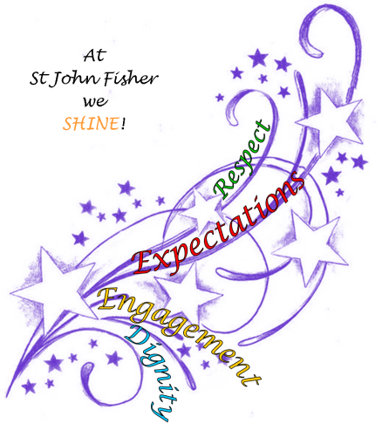
St John Fisher Catholic Primary School

Statement for Sex and Relationship Education (RSE)

The Governors at St John Fisher Catholic Primary School have adopted, “A Journey in Love” – a developmental Programme. This is the recommended resource for the teaching of Sex and Relationship Education because it is compiled specifically to present a Catholic vision. In each Year group, an aspect of love is explored and developed starting from Nursery to Year 6. Our pupils are encouraged to marvel at the wonder and beauty of God’s love reflected in each person under the components:

Physical, intellectual, social emotional and spiritual.

Each section has suggested progressive/developmental tasks/activities/reflections. Cross curricular links e.g. Come and See, science, art, drama, music, literacy, circle-time, worship, prayer and hymns.

OVERVIEW of Themes

Nursery: Wonder at God’s love.
Reception: God loves each of us in our uniqueness.
Year 1: We meet God’s love in our family.
Year 2: We meet God’s love in the community.
Year 3: How we live in God’s love.
Year 4: God loves us in our differences.
Year 5: God loves me in my changing and development.
Year 6: The wonder of God’s love in creating new life.

You have the right to withdraw your child from this aspect of the curriculum; however, this is not to be confused with curriculum Science which is statutory. If you require any further clarification regarding this aspect of the curriculum, please contact: Mrs M. Forrest– Headteacher.

